**Workshop Web Design**

**Pertemuan 6**



|  |  |  |
| --- | --- | --- |
| Nama | : | Defri Indra Mahardika |
| NRP | : | 3120510402 |
| PRODI | : | D3 PJJ TI B |
| TAHUN | : | 2020 |

1. Perocbaan 1

Source code :

<!DOCTYPE html>

<html lang="en">

<head>

<meta charset="UTF-8">

<meta name="viewport" content="width=device-width, initial-scale=1.0">

<title>Percobaan 1</title>

<link rel="stylesheet" href="https://stackpath.bootstrapcdn.com/bootstrap/4.5.2/css/bootstrap.min.css" integrity="sha384-JcKb8q3iqJ61gNV9KGb8thSsNjpSL0n8PARn9HuZOnIxN0hoP+VmmDGMN5t9UJ0Z" crossorigin="anonymous">

</head>

<body>

<div class="container bg-primary p-4 text-black">

<h1 class="text-white">My First bootstrap</h1>

<p>This part is inside .container class</p>

<p>

The .container class provides a responsive fixed width container

</p>

<p>

Resize the browser window to see that its width (max-width) will change at different breakpoints

</p>

</div>

<script src="https://code.jquery.com/jquery-3.5.1.slim.min.js" integrity="sha256-4+XzXVhsDmqanXGHaHvgh1gMQKX40OUvDEBTu8JcmNs=" crossorigin="anonymous"></script>

<script src="https://stackpath.bootstrapcdn.com/bootstrap/4.5.2/js/bootstrap.min.js" integrity="sha384-B4gt1jrGC7Jh4AgTPSdUtOBvfO8shuf57BaghqFfPlYxofvL8/KUEfYiJOMMV+rV" crossorigin="anonymous"></script>

<script src="https://stackpath.bootstrapcdn.com/bootstrap/4.5.2/js/bootstrap.bundle.min.js" integrity="sha384-LtrjvnR4Twt/qOuYxE721u19sVFLVSA4hf/rRt6PrZTmiPltdZcI7q7PXQBYTKyf" crossorigin="anonymous"></script>

</body>

</html>

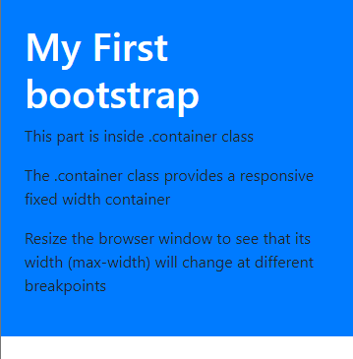

Penjelasan :

Pada bootstrap terdapat class yang bernama container, fungsinya yaitu untuk membuat content responsive secara otomatis tanpa menambahkan style apapun lagi.

1. Percobaan 2

Source Code :

<!DOCTYPE html>

<html lang="en">

<head>

<meta charset="UTF-8">

<meta name="viewport" content="width=device-width, initial-scale=1.0">

<title>Percobaan 2</title>

<link rel="stylesheet" href="https://stackpath.bootstrapcdn.com/bootstrap/4.5.2/css/bootstrap.min.css" integrity="sha384-JcKb8q3iqJ61gNV9KGb8thSsNjpSL0n8PARn9HuZOnIxN0hoP+VmmDGMN5t9UJ0Z" crossorigin="anonymous">

</head>

<body>

<div class="container p-4 text-black">

<h1 class="text-primary">Responsive Column</h1>

<p>

Ubah ukuran browser untuk melihat efeknya.

</p>

<div class="row">

<div class="col-s-3 text-white bg-primary p-2">.col-sm-3</div>

<div class="col-s-3 text-white bg-warning p-2">.col-sm-3</div>

<div class="col-s-3 text-white bg-danger p-2">.col-sm-3</div>

<div class="col-s-3 text-white bg-success p-2">.col-sm-3</div>

</div>

</div>

<script src="https://code.jquery.com/jquery-3.5.1.slim.min.js" integrity="sha256-4+XzXVhsDmqanXGHaHvgh1gMQKX40OUvDEBTu8JcmNs=" crossorigin="anonymous"></script>

<script src="https://stackpath.bootstrapcdn.com/bootstrap/4.5.2/js/bootstrap.min.js" integrity="sha384-B4gt1jrGC7Jh4AgTPSdUtOBvfO8shuf57BaghqFfPlYxofvL8/KUEfYiJOMMV+rV" crossorigin="anonymous"></script>

<script src="https://stackpath.bootstrapcdn.com/bootstrap/4.5.2/js/bootstrap.bundle.min.js" integrity="sha384-LtrjvnR4Twt/qOuYxE721u19sVFLVSA4hf/rRt6PrZTmiPltdZcI7q7PXQBYTKyf" crossorigin="anonymous"></script>

</body>

</html>

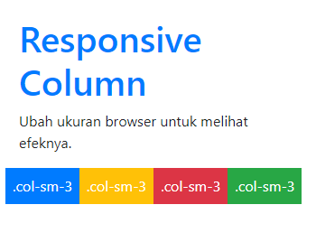

Penjelasan :

Dalam bootstrap terdapat class .col-*-* yang dapat digunakan untuk mempermudah pengaturan layout. Class col ini dapat diletakkan didalam class .row

1. Percobaan 3

Source Code:

<!DOCTYPE html>

<html lang="en">

<head>

<meta charset="UTF-8">

<meta name="viewport" content="width=device-width, initial-scale=1.0">

<title>Percobaan 3</title>

<link rel="stylesheet" href="https://stackpath.bootstrapcdn.com/bootstrap/4.5.2/css/bootstrap.min.css" integrity="sha384-JcKb8q3iqJ61gNV9KGb8thSsNjpSL0n8PARn9HuZOnIxN0hoP+VmmDGMN5t9UJ0Z" crossorigin="anonymous">

</head>

<body>

<div class="container p-4 text-black">

<h1 class="text-primary">Lighter, Secondary Text</h1>

<p>

The small element is used to create a lighter, secondary text in any heading : .

</p>

<h1> h1 heading <small>secondary text</small></h1>

<h2> h2 heading <small>secondary text</small></h2>

<h3> h3 heading <small>secondary text</small></h3>

<h4> h4 heading <small>secondary text</small></h4>

<h5> h5 heading <small>secondary text</small></h5>

<h6> h6 heading <small>secondary text</small></h6>

</div>

<script src="https://code.jquery.com/jquery-3.5.1.slim.min.js" integrity="sha256-4+XzXVhsDmqanXGHaHvgh1gMQKX40OUvDEBTu8JcmNs=" crossorigin="anonymous"></script>

<script src="https://stackpath.bootstrapcdn.com/bootstrap/4.5.2/js/bootstrap.min.js" integrity="sha384-B4gt1jrGC7Jh4AgTPSdUtOBvfO8shuf57BaghqFfPlYxofvL8/KUEfYiJOMMV+rV" crossorigin="anonymous"></script>

<script src="https://stackpath.bootstrapcdn.com/bootstrap/4.5.2/js/bootstrap.bundle.min.js" integrity="sha384-LtrjvnR4Twt/qOuYxE721u19sVFLVSA4hf/rRt6PrZTmiPltdZcI7q7PXQBYTKyf" crossorigin="anonymous"></script>

</body>

</html>

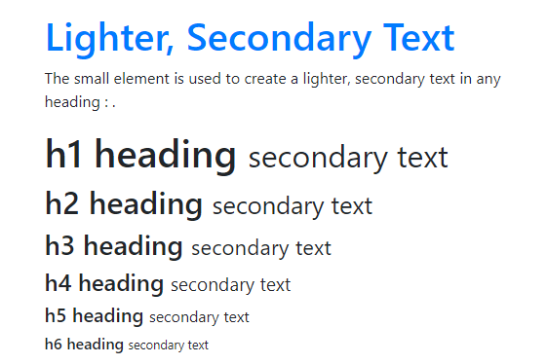

Penjelasan :

Dalam bootstrap heading sudah mempunyai style nya sendiri , jadi kita tidak perlu menambahkan style apapun

1. Percobaan 4

Source Code :

<!DOCTYPE html>

<html lang="en">

<head>

<meta charset="UTF-8">

<meta name="viewport" content="width=device-width, initial-scale=1.0">

<title>Percobaan 3</title>

<link rel="stylesheet" href="https://stackpath.bootstrapcdn.com/bootstrap/4.5.2/css/bootstrap.min.css" integrity="sha384-JcKb8q3iqJ61gNV9KGb8thSsNjpSL0n8PARn9HuZOnIxN0hoP+VmmDGMN5t9UJ0Z" crossorigin="anonymous">

</head>

<body>

<div class="container p-4 text-black">

<h1 class="text-primary">Contextual Background</h1>

<p class="bg-primary text-white p-1"> Test background color</p>

<p class="bg-info text-white p-1"> Test background color</p>

<p class="bg-success text-white p-1"> Test background color</p>

<p class="bg-danger text-white p-1"> Test background color</p>

<p class="bg-warning text-white p-1"> Test background color</p>

</div>

<script src="https://code.jquery.com/jquery-3.5.1.slim.min.js" integrity="sha256-4+XzXVhsDmqanXGHaHvgh1gMQKX40OUvDEBTu8JcmNs=" crossorigin="anonymous"></script>

<script src="https://stackpath.bootstrapcdn.com/bootstrap/4.5.2/js/bootstrap.min.js" integrity="sha384-B4gt1jrGC7Jh4AgTPSdUtOBvfO8shuf57BaghqFfPlYxofvL8/KUEfYiJOMMV+rV" crossorigin="anonymous"></script>

<script src="https://stackpath.bootstrapcdn.com/bootstrap/4.5.2/js/bootstrap.bundle.min.js" integrity="sha384-LtrjvnR4Twt/qOuYxE721u19sVFLVSA4hf/rRt6PrZTmiPltdZcI7q7PXQBYTKyf" crossorigin="anonymous"></script>

</body>

</html>

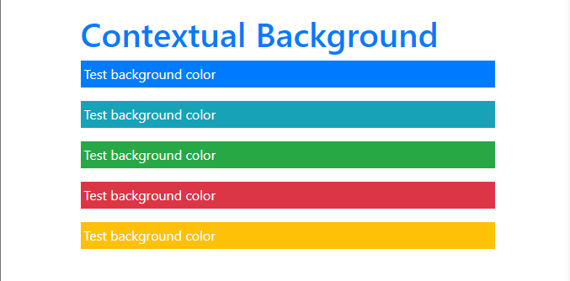

Penjelasan :

Dalam bootstrap juga terdapat color yang sudah ditetapkan oleh pihak pengembang, color ini dapat digunakan untuk background, text dan juga yang lainnya.

1. Percobaan 5

Source code :

<!DOCTYPE html>

<html lang="en">

<head>

<meta charset="UTF-8">

<meta name="viewport" content="width=device-width, initial-scale=1.0">

<title>Percobaan 3</title>

<link rel="stylesheet" href="https://stackpath.bootstrapcdn.com/bootstrap/4.5.2/css/bootstrap.min.css" integrity="sha384-JcKb8q3iqJ61gNV9KGb8thSsNjpSL0n8PARn9HuZOnIxN0hoP+VmmDGMN5t9UJ0Z" crossorigin="anonymous">

</head>

<body>

<div class="container p-4 text-black">

<h1 class="text-primary">Hover Row</h1>

<table class="table table-responsive table-borderless">

<thead>

<th>NRP</th>

<th>Nama</th>

</thead>

<tbody>

<td>3120510402</td>

<td>Defri Indra Mahardika</td>

</tbody>

</table>

</div>

<script src="https://code.jquery.com/jquery-3.5.1.slim.min.js" integrity="sha256-4+XzXVhsDmqanXGHaHvgh1gMQKX40OUvDEBTu8JcmNs=" crossorigin="anonymous"></script>

<script src="https://stackpath.bootstrapcdn.com/bootstrap/4.5.2/js/bootstrap.min.js" integrity="sha384-B4gt1jrGC7Jh4AgTPSdUtOBvfO8shuf57BaghqFfPlYxofvL8/KUEfYiJOMMV+rV" crossorigin="anonymous"></script>

<script src="https://stackpath.bootstrapcdn.com/bootstrap/4.5.2/js/bootstrap.bundle.min.js" integrity="sha384-LtrjvnR4Twt/qOuYxE721u19sVFLVSA4hf/rRt6PrZTmiPltdZcI7q7PXQBYTKyf" crossorigin="anonymous"></script>

</body>

</html>



Penjelasan :

Didalam bootstrap penggunaan table sangat dimudahkan kita dapat memberikan banyak style terhadapat sebuah table , contohnya adalah .table-responsive.

1. Percobaan 6

Source code :

<!DOCTYPE html>

<html lang="en">

<head>

<meta charset="UTF-8">

<meta name="viewport" content="width=device-width, initial-scale=1.0">

<title>Percobaan 3</title>

<link rel="stylesheet" href="https://stackpath.bootstrapcdn.com/bootstrap/4.5.2/css/bootstrap.min.css" integrity="sha384-JcKb8q3iqJ61gNV9KGb8thSsNjpSL0n8PARn9HuZOnIxN0hoP+VmmDGMN5t9UJ0Z" crossorigin="anonymous">

</head>

<body>

<div class="container p-4 text-black">

<h1 class="text-primary">Image</h1>

<img src="https://source.unsplash.com/110x110" alt="Random Image" class="img img-fluid img-thumbnail">

<img src="https://source.unsplash.com/110x110" alt="Random Image" class="img img-fluid rounded-circle">

</div>

<script src="https://code.jquery.com/jquery-3.5.1.slim.min.js" integrity="sha256-4+XzXVhsDmqanXGHaHvgh1gMQKX40OUvDEBTu8JcmNs=" crossorigin="anonymous"></script>

<script src="https://stackpath.bootstrapcdn.com/bootstrap/4.5.2/js/bootstrap.min.js" integrity="sha384-B4gt1jrGC7Jh4AgTPSdUtOBvfO8shuf57BaghqFfPlYxofvL8/KUEfYiJOMMV+rV" crossorigin="anonymous"></script>

<script src="https://stackpath.bootstrapcdn.com/bootstrap/4.5.2/js/bootstrap.bundle.min.js" integrity="sha384-LtrjvnR4Twt/qOuYxE721u19sVFLVSA4hf/rRt6PrZTmiPltdZcI7q7PXQBYTKyf" crossorigin="anonymous"></script>

</body>

</html>



Penjelasan :

Dalam bootstrap style untuk image pun juga dipermudah, untuk contoh penggunaan bootstrap pada image adalah seperti diatas.